The Legal Case of Fukushima:

Energy policy and what the EU has (not) learnt about nuclear liability

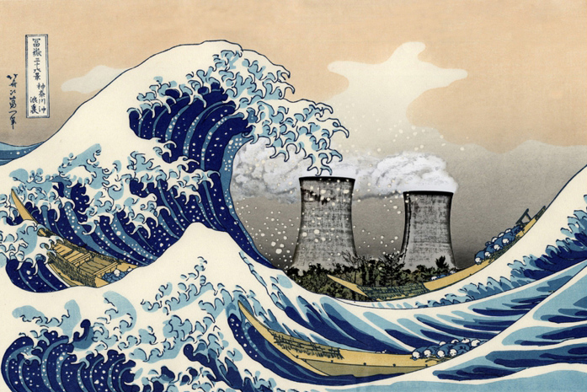

Public talk by Julius Weitzdörfer

With victims’ claims exceeding 100 billion Euros and an unprecedented number of over two million plaintiffs, Fukushima constitutes the largest civil liability case in history. Despite the legal liability of the plant operator, rescued by state aids, the burden of costs falls upon the taxpayers.
In the light of climate change and nuclear new-builds in Poland, England, Russian-equipped Romania and earthquake-prone Turkey, nuclear energy as well as liability for cross-border accidents are staying high on the EU’s agenda. Recently, the Commission introduced its long-promised proposal on a strengthened liability and insurance regime, both outraging the industry and disappointing activists.
Drawing upon field-research in Japan and a comparison to the reforms in the EU, this talk will give a first-hand critical account of the compensation of the victims of Fukushima, the fight of the lobbyists in Brussels and legal lessons to be learnt from the disaster.

Wednesday, April 23, 2014, 6:00 pm
Campus Westend, PEG building, room PEG 1. G 192

Julius Weitzdörfer studied Journalism and Japanese in Tokyo and Leipzig as well as law in Hamburg, Shanghai and Kyoto. He is a fellow of the project team for the research project “Protecting the weak at the Interdisciplinary Centre for East-Asian Studies. Entangled Processes of Framing, Mobilization and Institutionalization in East Asia” funded by the Volkswagen Foundation and a Research Fellow at Darwin College, University of Cambridge.

Ansprechpartner: Prof. Heike Holbig, FB03, Institut für Politikwissenschaft; Email: holbig@soz.uni-frankfurt.de

